Assignment 2

S. Francin Samuel

20BCE2836

**File and directory manipulation**

1.





2.



3.





4.

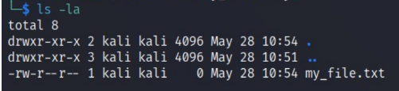

5.



6.



7.



8.



9.



**Permissions and Scripting**

1.



2.





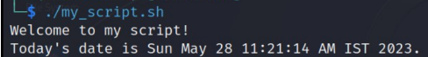

**Command execution and pipelines**

